Product Introduction
Backpack Style Drone Suppressor

Model:TTSK--FQ-28

Manual Description
This product meets the design requirements for environmental protection and personal safety. The storage, use, and disposal of the product should comply with the requirements of the product manual, relevant contracts, or relevant national laws and regulations.
This manual describes the features, technical parameters and operation instructions of the backpack-mounted UAV countermeasures equipment
The use equipment may be restricted by local laws and regulations, please ensure legal compliance and comply with relevant regulations before use.

Product Introduction
This product is mainly used for drone suppressing, driving and forced landing of drones within the range of vision. This device can be set according to customer requirements (frequency band power color appearance) using backpack, can be carried for a long time, built-in battery, unlimited use more convenient, to meet a variety of use needs especially suitable for application: Large venues, counter-terrorism units, anti-drug units, riot squads, bomb disposal squads, checkpoints, hostage negotiations and border control, etc.

Product Details
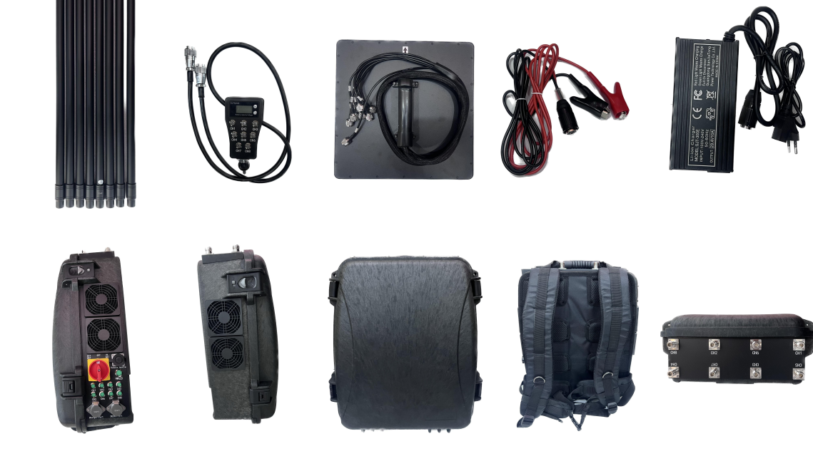

Product features
- Multi-channel countermeasures.
- The design of slow start circuit can avoid the ignition phenomenon caused by mechanical switch, high integration and stable operation.
- Supporting external omnidirectional antenna and hand-held directional
antenna mode to meet a variety of needs.
- Knapsack design, flexible application, especially suitable for emergency, transition, temporary control and other use needs.
- Built-in charging battery, can be used for 40-60 minutes after full charge.
- Box selection of high instrument standard chassis, anti-fall and compression, strong and durable.
- Power supply mode: powered by built-in battery, power supply (DC24V); The built-in efficient cooling fan and heat sink are combined to ensure the overall stable working performance and long service life.
- Multiple adjustment, each segment can individually enable or disable a different segment. The omnidirectional glass fiber reinforced plastic high optimization antenna, good counter distance, can also choose a variety of antennas, according to the user's geographical environment flexible planning shielding range.
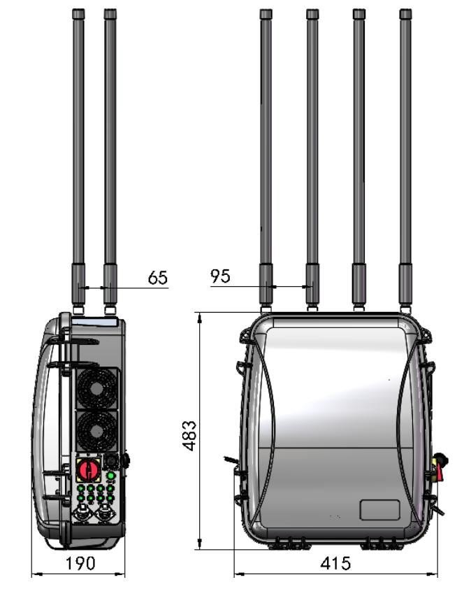

Main parameters

Equipment parameters
Counter parameter | Counter frequency band 1 | 420-430MHz，50W/47+1dbm
Counter parameter | Counter frequency band 2 | 860-930MHz，50W/47+1dbm
Counter parameter | Counter frequency band 3 | 1160-1280MHz，50W/47+1dbm
Counter parameter | Counter frequency band 4 | 1370-1450MHz，50W/47+1dbm
Counter parameter | Counter frequency band 5 | 1550-1636MHz，50W/47+1dbm
Counter parameter | Counter frequency band 6 | 2380-2500MHz，50W/47+1dbm
Counter parameter | Counter frequency band 7 | 5150-5350MHz，50W/47+1dbm
Counter parameter | Counter frequency band 8 | 5725-5850MHz，50W/47+1dbm
Counter parameter | Frequency band and power can be customized  According to requirements
Structural  parameter | Backpack size | 415*190*483mm
Structural  parameter | Set weight | 23.8kg
Structural  parameter | Battery size | 265*115*80mm
Structural  parameter | Battery weight | 4.15kg
Structural  parameter | Battery life | 40-60min
Structural  parameter | Charge mode | 29.4V charging adapter

Product List
NO. | Name | Units | Quantity | Remarks
1 | Host(battery included) | set | 1 | 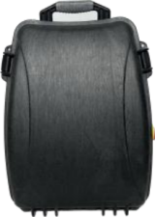
2 | Omnidirectional antenna | pcs | 8 | 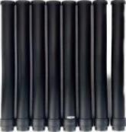
3 | Directional antenna | set | 1 | 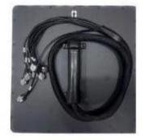
4 | Controller | set | 1 | 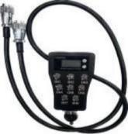
5 | Charger | set | 1 | 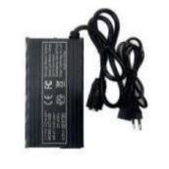
6 | External power cord | PC | 1 | 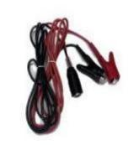
7 | Instructions | piece | 1 | 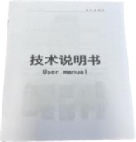
8 | Packing Box | piece | 1 | 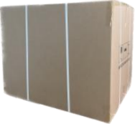

Operating instruction

Note: Before turning on the device, please make sure that the device is fully charged and that the antenna is installed correctly. Only after the antenna is installed correctly can you turn on the power and put it into use.
1.Check whether the appearance of the device is intact. Check the product list (omnidirectional antenna, control handle, control cable, handheld directional plate antenna. External power cable,charger) to see whether the accessories are complete, the erection environment is as clear as possible, and the voltage is sufficient.
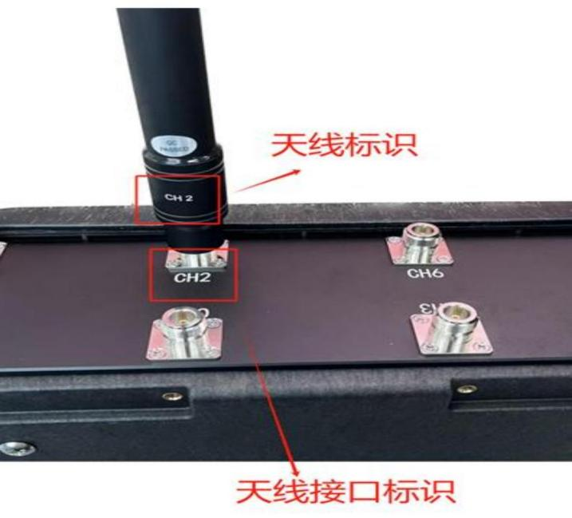
2.Correspond the identifiers on the omnidirectional antenna or handheld directional plate antenna to the identifiers on the device antenna interface, and then tighten the antenna to the antenna interface.

3.Connect the control cable and control handle to the device control handle port.
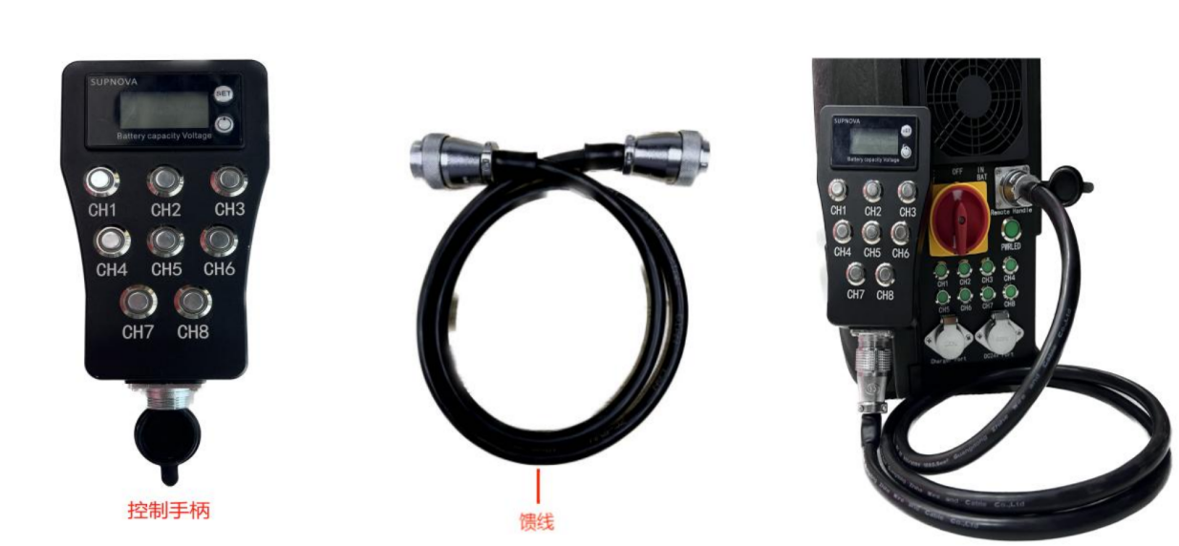
Device startup:
Method 1 "Turn the main switch to the right to the built-in battery mode, wait about 5 seconds for the device to start";
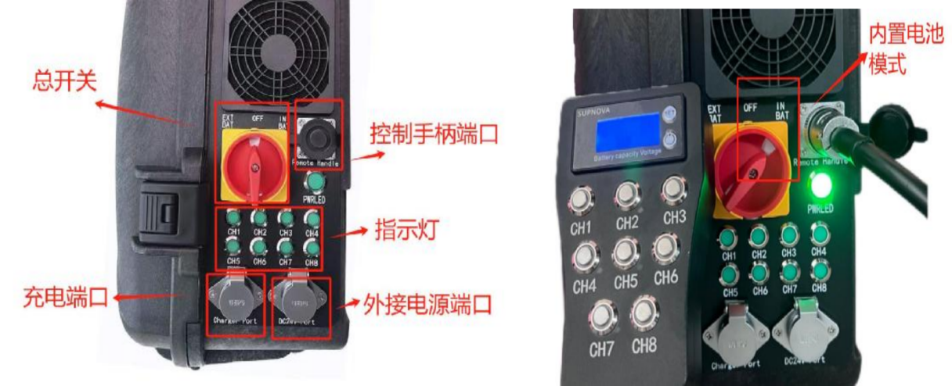
Method 2: Use the external power cable to connect the DC24V external power port, turn the main switch left to the external power mode, and wait about 5 seconds for the device to start

The battery level display screen can display the current battery level of
the device.
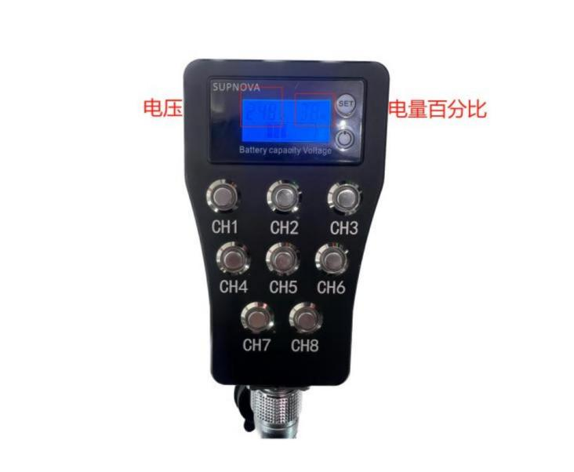
Start and end counter: Press the channel strobe button (CH1-CH8) and the selected
channel will start working when the indicator lights up. After 30 seconds, the countermeasure begins: press the channel strobe button again, the light goes out, and the countermeasure ends.
